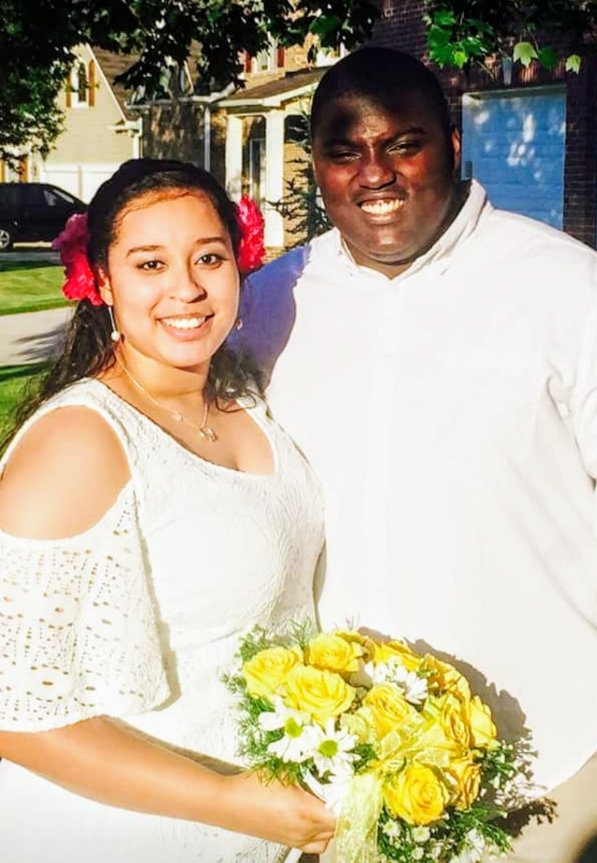
Mrs. Krystle Holland, formerly known as Krystle Wilburn, graduated from Warren County High School in 2012. She spoke of her plan, while still in high school, to return and replace Mr. Bill Vaughan, her favorite teacher. In the fall of 2012, Krystle attended the University of West Georgia, where she earned a Bachelors of Science Degree in Chemistry and a Teaching Certification in General Science with cum laude honors. Krystle now teaches at Warren County High School in the position she spoke of 6 years ago. She teaches Environmental Science, Physical Science, and Chemistry to the students of Warren County High School. She is married to Mr. David Holland, whom she met at West Georgia, and lives in Grovetown. She and her husband are currently both teachers and are each pursuing a Master's Degree in Curriculum and Instruction at Georgia Southern University.

